Lab 1: Connection of Network Devices Using Ethernet
Materials Required:
- Ethernet cable
- RJ45 connectors
- Crimping tool
- Wire stripper
- Cable tester
Theory
Introduction to Ethernet Cables
Ethernet cables are the physical medium used to transmit data between network devices in local area networks (LANs). These cables contain twisted pairs of copper wires that carry electrical signals representing digital data. The twisting of wire pairs helps reduce electromagnetic interference (EMI) and crosstalk between adjacent pairs.
Cable Categories
Modern Ethernet cables are categorized based on their performance specifications:
- Cat5e (Category 5 enhanced): Supports speeds up to 1 Gbps at 100 MHz bandwidth, suitable for most home and office networks
- Cat6 (Category 6): Supports speeds up to 10 Gbps for shorter distances (up to 55 meters) at 250 MHz bandwidth, with improved shielding against interference
- Cat6a and higher: Support higher frequencies and longer distances for 10 Gbps transmission
Wiring Standards
Two primary wiring standards exist for terminating Ethernet cables:
T568A Standard:
- Pin 1: White/Green
- Pin 2: Green
- Pin 3: White/Orange
- Pin 4: Blue
- Pin 5: White/Blue
- Pin 6: Orange
- Pin 7: White/Brown
- Pin 8: Brown
T568B Standard:
- Pin 1: White/Orange
- Pin 2: Orange
- Pin 3: White/Green
- Pin 4: Blue
- Pin 5: White/Blue
- Pin 6: Green
- Pin 7: White/Brown
- Pin 8: Brown
Both standards are functionally equivalent, but T568B is more commonly used in commercial installations.
Cable Types and Applications
Straight-through Cable:
A straight-through cable uses the same wiring standard on both ends. This configuration is used to connect different types of devices, such as:
- Computer to switch/hub
- Router to switch/hub
- Computer to router
Crossover Cable:
A crossover cable uses T568A on one end and T568B on the other end. This configuration physically crosses the transmit and receive pairs, allowing direct communication between similar devices:
- Computer to computer
- Switch to switch
- Router to router

Pin Functions in Ethernet
In standard 100BASE-TX and 1000BASE-T Ethernet:
- Pins 1-2: Transmit data (TX+ and TX-)
- Pins 3-6: Receive data (RX+ and RX-)
- Pins 4-5, 7-8: Used for Power over Ethernet (PoE) or for Gigabit Ethernet bidirectional transmission
Cable Testing Principles
Cable testers verify the continuity and correct wiring of all eight conductors. They work by:
- Sending signals through each wire from the transmitter unit
- Detecting these signals at the receiver unit
- Comparing the expected pin configuration with the actual connections
- Identifying faults such as open circuits, short circuits, crossed wires, or split pairs

Preparation of Ethernet Cable with RJ45 Connectors
Type 1: Straight-through Cable
- Cut the Ethernet cable to the desired length.
- Strip about 1 inch of the outer jacket from both ends of the cable using the wire stripper.
- Untwist the pairs of wires and arrange them according to the T568B wiring standard:
  - Pin 1: White/Orange
  - Pin 2: Orange
  - Pin 3: White/Green
  - Pin 4: Blue
  - Pin 5: White/Blue
  - Pin 6: Green
  - Pin 7: White/Brown
  - Pin 8: Brown

- Trim the wires to ensure they are all the same length.
- Insert the wires into the RJ45 connector, ensuring each wire goes into its respective slot.
- Use the crimping tool to secure the RJ45 connector onto the cable.
- Repeat steps 2-6 for the other end of the cable.
- Test the cable using a cable tester to ensure proper connectivity.
Type 2: Crossover Cable
- Follow steps 1-4 from the straight-through cable procedure.
- For one end of the cable, arrange the wires according to the T568A wiring standard:
  - Pin 1: White/Green
  - Pin 2: Green
  - Pin 3: White/Orange
  - Pin 4: Blue
  - Pin 5: White/Blue
  - Pin 6: Orange
  - Pin 7: White/Brown
  - Pin 8: Brown
- For the other end of the cable, arrange the wires according to the T568B wiring standard:
  - Pin 1: White/Orange
  - Pin 2: Orange
  - Pin 3: White/Green
  - Pin 4: Blue
  - Pin 5: White/Blue
  - Pin 6: Green
  - Pin 7: White/Brown
  - Pin 8: Brown
- Trim the wires to ensure they are all the same length.
- Insert the wires into the RJ45 connectors, ensuring each wire goes into its respective slot.
- Use the crimping tool to secure the RJ45 connectors onto the cable.
- Test the cable using a cable tester to ensure proper connectivity.

Connection Testing Using Cable Tester
- Connect one end of the cable to the transmitter unit of the cable tester.
- Connect the other end of the cable to the receiver unit of the cable tester.
- Turn on the cable tester and observe the results.
  - For a straight-through cable, all pairs should show continuity in the same order.
  - For a crossover cable, the transmit and receive pairs should be crossed.
  - Orders: 1-8 for straight-through and 1-3, 2-6, 3-1, 6-2 for crossover.

Output: Straight-through
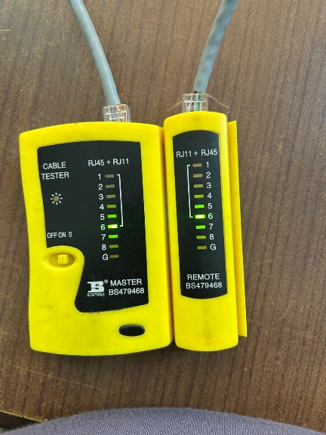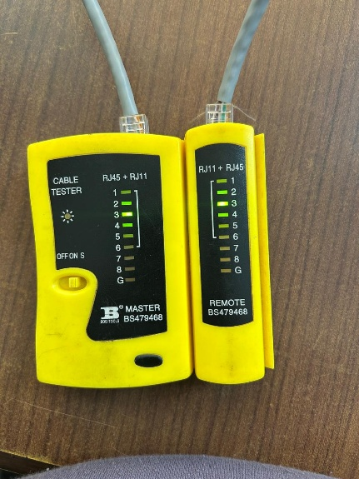
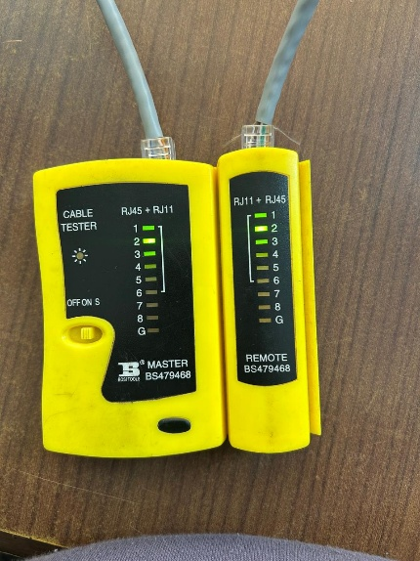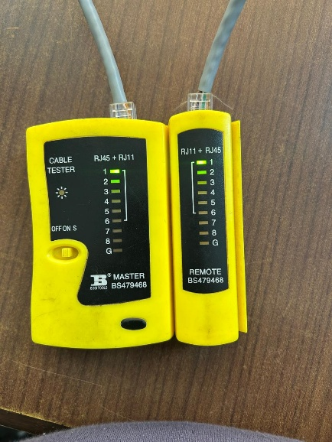

Output: Crossover
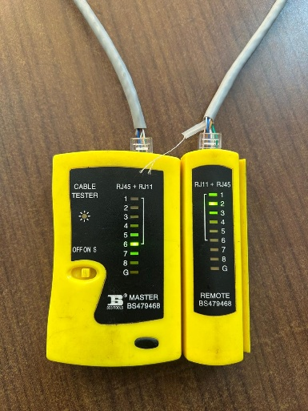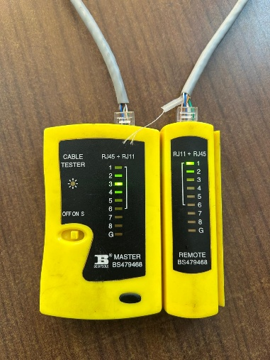
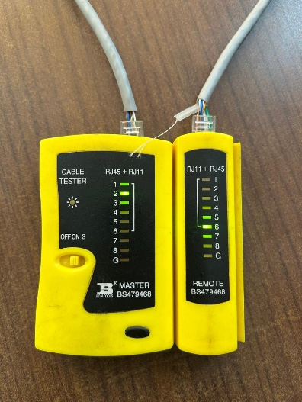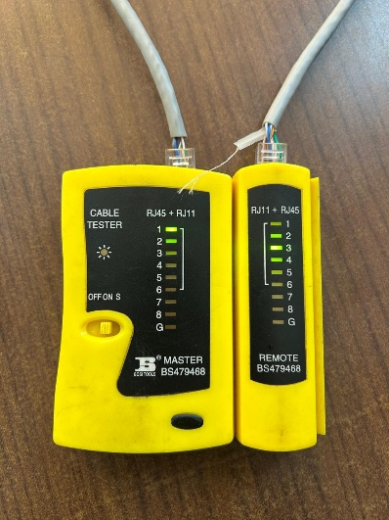

Results
The cable tester indicates that all wires are properly connected and there are no faults. Both straight-through and crossover cables were successfully constructed and tested, demonstrating proper understanding of Ethernet cable termination standards.

